LAB # 10
Indexing In MongoDB

Objectives :
To learn and implement different types of indexes in MongoDB

Lab Tasks :

1. Create a collection named "products" and insert at least 10 documents.

Code
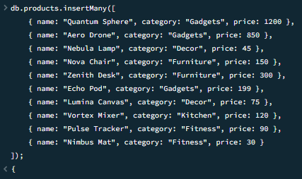
2. Create a compound index on the "category" and "price" fields. Write a query that utilizes the index created.
Code
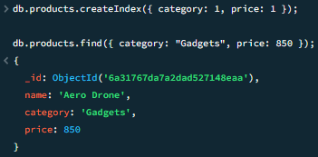
3. Write a query that utilizes the newly created index to find products in a specific category with prices greater than a certain value. (Note: Explore the implementation of for loop, keyword ‘const’ and embed it in this query result.

Code
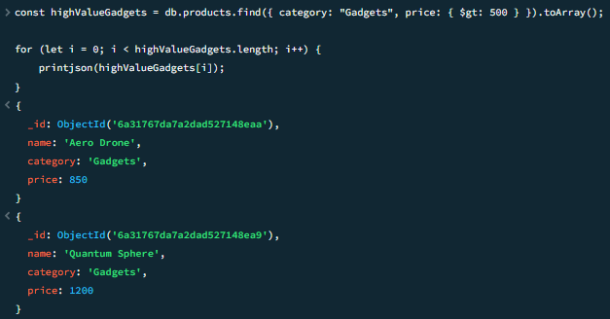
4. Create a text index on the field category.

Code
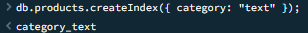
5. Create an index with key -1 and observe the difference.

Code
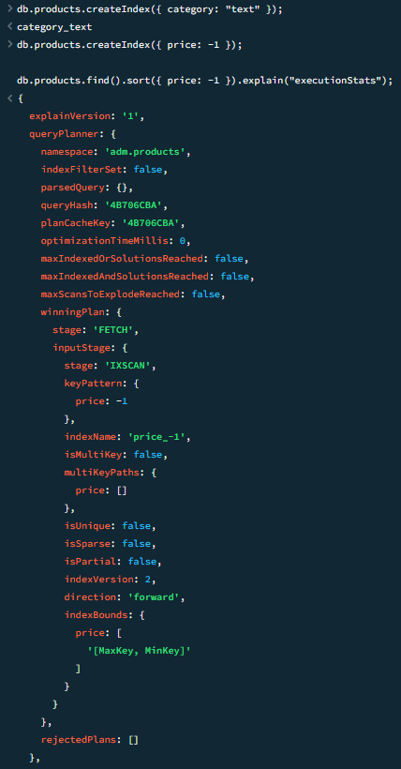

Code
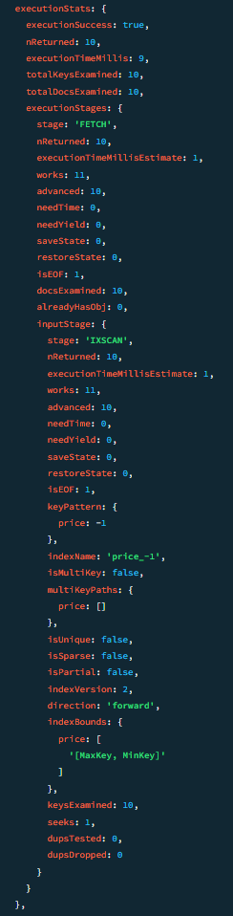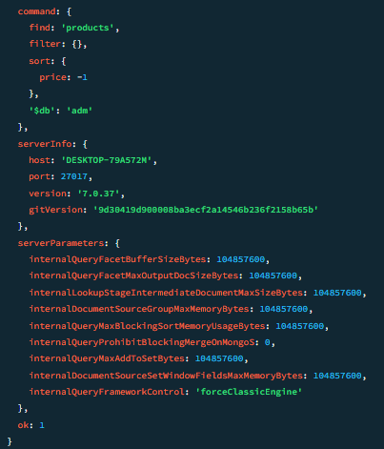

6. Create a collection named "articles" with documents containing "title" and "content" fields. Create a text index on the "content" field. Perform a text search to find articles containing a specific keyword. (Note: Explore the implementation of for loop, keyword ‘const’ and embed it in this query result.

Code
